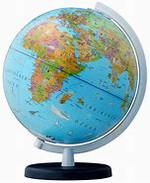
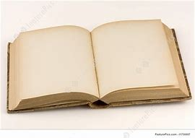
Read/watch more to know more!

Title of article/programme

Summarise the article/programme in 5 main points:
1.

2.

3.

4.

5.

Identify and define 5 pieces of amazing geographical vocabulary:
1.

2.

3.

4.

5.

How does this article/programme link to your topics?

Can you create some exam questions you could use this information for?
1.

2.

3.

How reliable is this article/programme? Explain your decision.

Superstar challenge: can you link this to any other articles/progammes?

