What to do today
IMPORTANT Parent or Carer – Read this page with your child and check that you are happy with what they have to do and any weblinks or use of internet.

1. Read a set of instructions
- Watch the reading of Zoo by Anthony Browne
https://www.youtube.com/watch?v=T07u0AggVsg
- What do you like about the story? Is there anything that you dislike about it? Does it remind you of anything that has happened to you? Does it remind you of any books that you have read?

2. Remind yourself about adverbials
- Use the PowerPoint teaching adverbials to understand how to use these. Or, if this is not possible, remind yourself using the Revision Card.
- Complete Zoo Adverbials. You could challenge yourself to write two new versions of each sentence. Can you change the emotion by the adverbials that you add?

3. Now for some writing
- Think about a day out for you. Talk to someone about a daytrip that you would REALLY like to have. Be as imaginative and fantastic as you want!
- Write about what you would do. Use adverbials in some sentences.

Well done! Share your writing with a grown-up. Show them the adverbials that you have included in your writing.

Try the Fun-Time Extras
- Can you find some more stories by Anthony Browne?
- Can you find out some information about Anthony Browne? You could start here:
http://www.anthonybrownebooks.com/

Adverbials – Revision Card
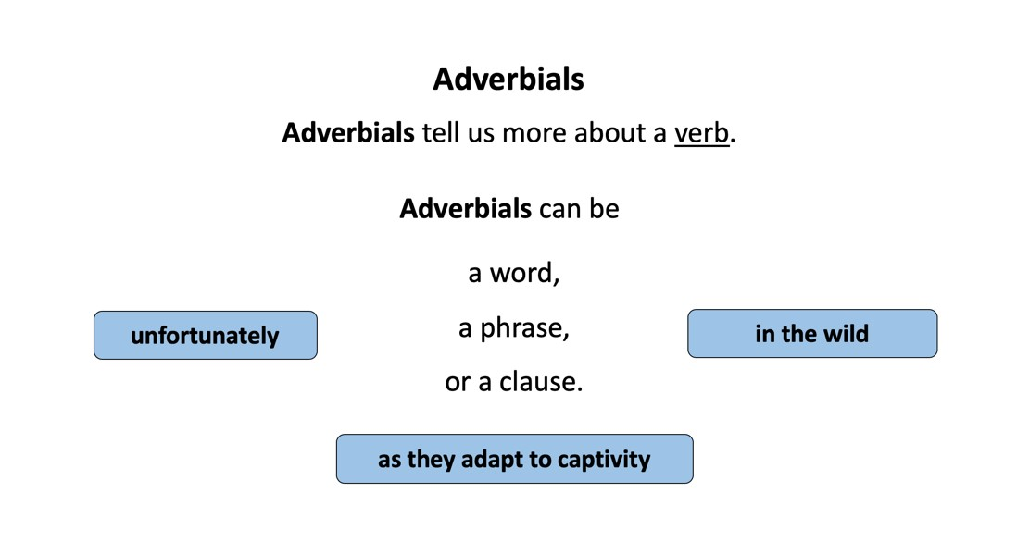
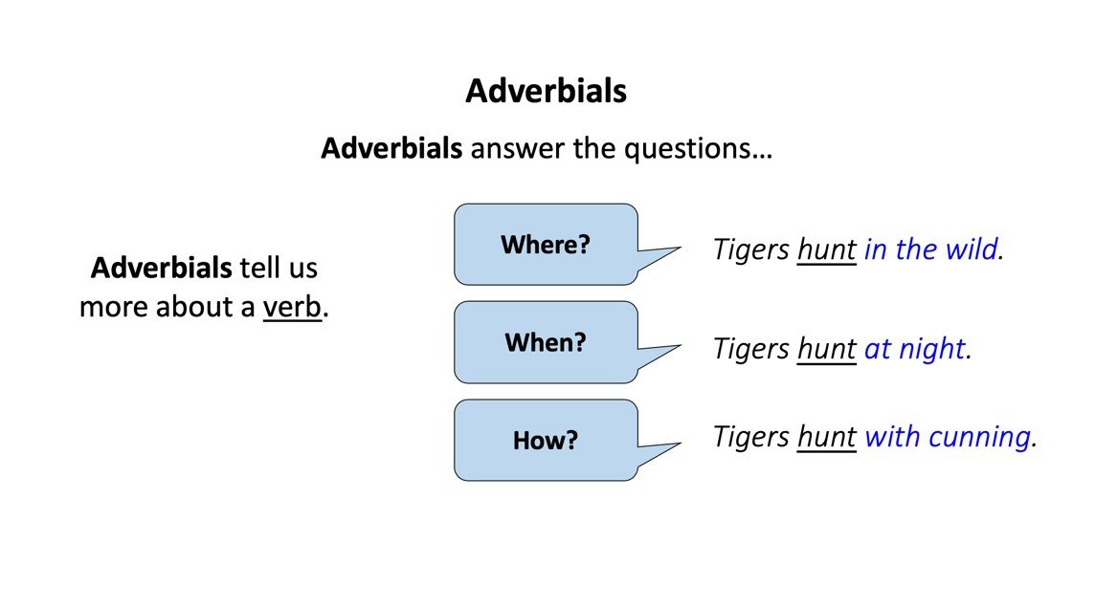
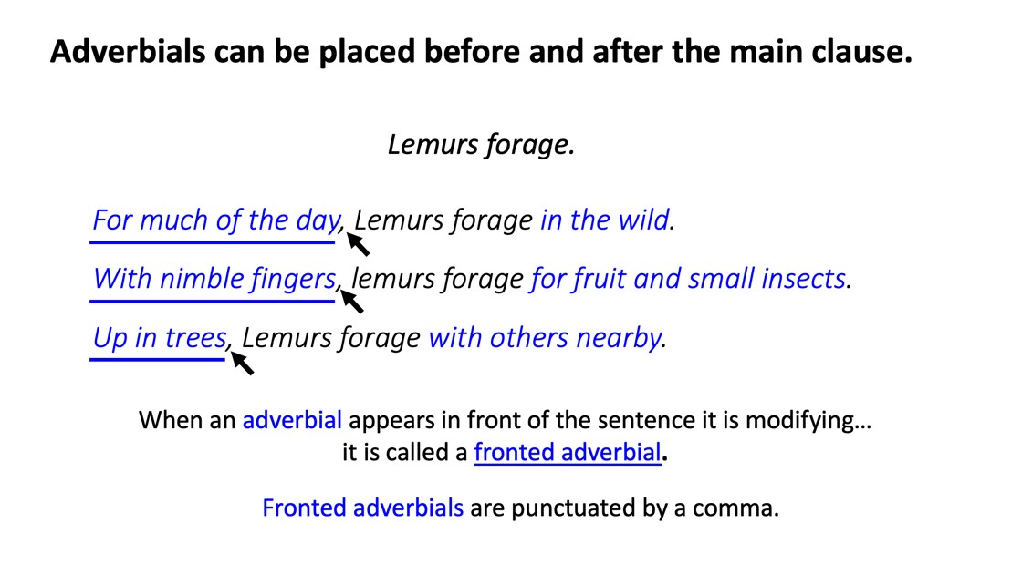

Zoo Adverbials

Try adding adverbials to change the impact.
Try making the zoo seem a good or bad place to be.
Or make your reader impressed, scared, bored or sorry for the zoo animals.

- The tiger paced.
- The elephant chewed.
- Some giraffes ambled.
- The meerkat watched.
- The rhinoceros stamped.
- The penguins waddled.
- A polar bear sniffed.
- Two baboons fought.
- The orangutan crouched.
10. A gorilla stared.

Adverbials often start with a preposition.
Use some of these then see if you can think of different ones to use.

Prepositions

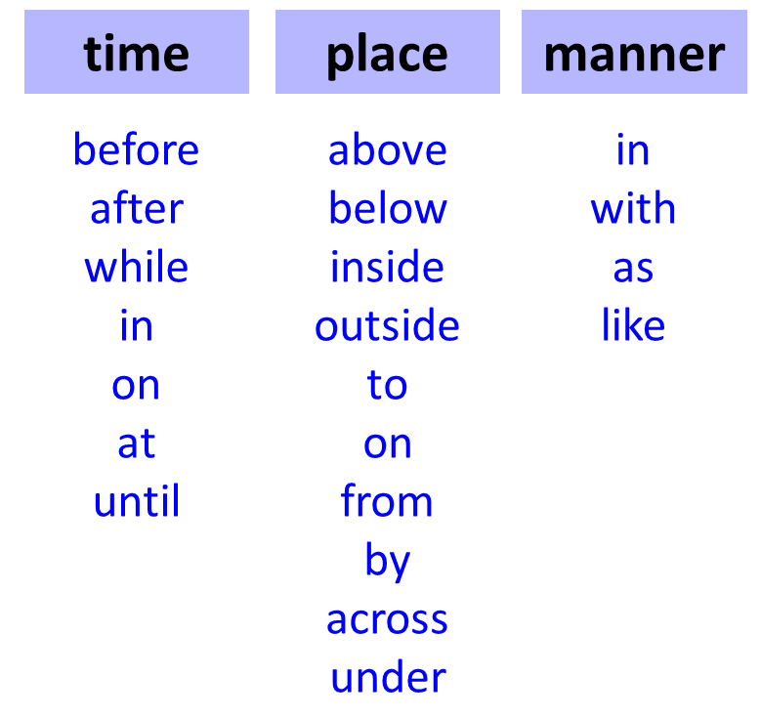

My Day Out

Write about a day out that you would REALLY like to have. Include sentences with adverbials.

