Send me your work or any questions at ccs@tda.education
¡Hola chicos y chicas!
Write the date in Spanish on your book:

Hoy es___________, _____de______________del 2020

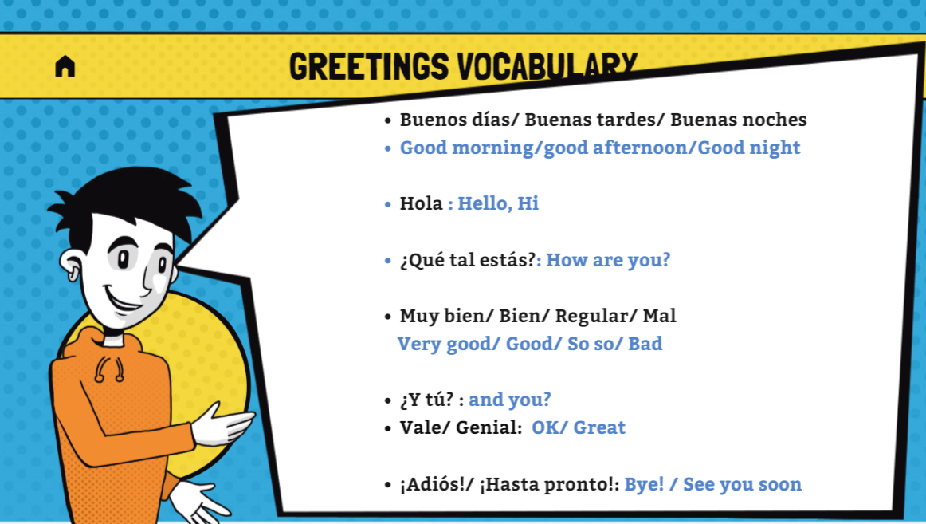

Now look at the example of two people meeting in the Street. This is a normal conversation you would have with someone you know.
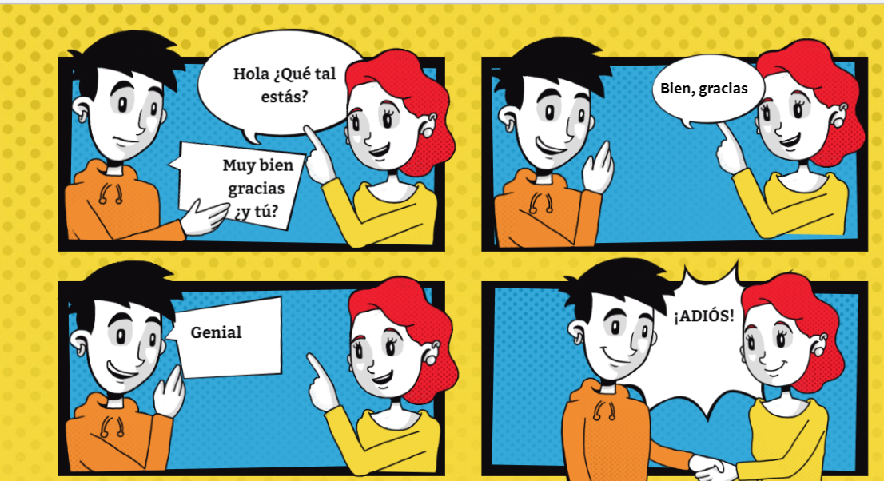

Now, Can you use different words from the “Greetings Vocabulary” and créate your own dialogue.
For example instead of Hola you can say Buenos días.

You can use the bellow comic or créate your own characters!

