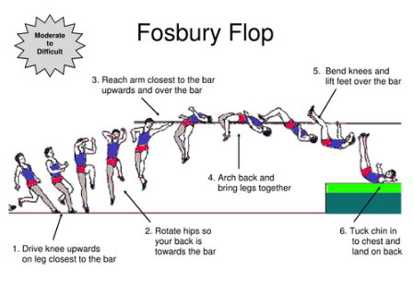
High Jump
How it works:
High jump is a track and field athletics event in which athletes jump over a horizontal bar placed at measured heights without the aid of any devices. Jumpers must take off on one foot. A jump is considered a failure if the bar is dislodged by the action of the jumper whilst jumping or the jumper touches the ground or breaks the plane of the near edge of the bar before clearance. The technique one uses for the jump must be almost flawless in order to have a chance of clearing a high bar.
Competitors may begin jumping at any height announced by the chief judge, or may pass, at their own discretion. Most competitions state that three consecutive missed jumps, at any height or combination of heights, will eliminate the jumper from competition.

History:
The high jump was first practised in England in the 19th century. It became an Olympic sport in 1896 for men and in 1928 for women. The most important aspect to put of all pieces of the jump together is the body mechanics the jumper uses to jump. Technique and form has evolved greatly over the history of high jump. The popularity of a style depend upon the time period as listed here:
Beginnings (1790 - 1875) --> two legged lift over bar / Basic Scissors (1875 - 1892) --> standing jump and straight run-up / Eastern Cut-off scissors (1892 - 1912) --> scissors with rotation / Western Roll (1912 - 1930) --> early straddle technique / Straddle (1930 - 1960) --> basic straddle technique / Dive Straddle (1960 - 1978) --> advanced straddle technique / Fosbury Flop (1968 - current) --> the currently most common technique used /

Did you know?:
Every athlete has three attempts on every height. The athletes are allowed to touch the bar but they must not knock it down.
There is a technique called the Fosbury flop and scissor kick.
Most high jumpers run at the bar at a 30 or 40 degree angle.
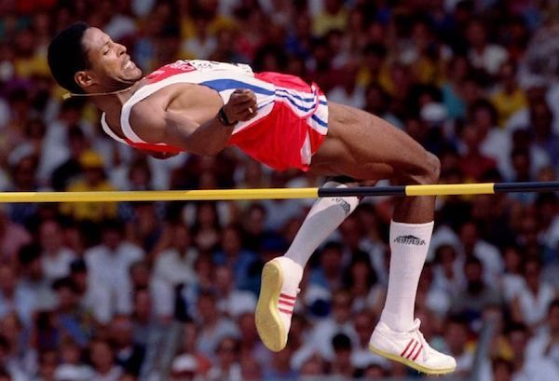
World records:
Javier Sotomayor (Cuba) is the current men's record holder with a jump of 2.45 m (8 ft ¹⁄₄ in) set in 1993 – the longest standing record in the history of the men's high jump. https://www.youtube.com/watch?time_continue=6&v=VCg6_fuipp8&feature=emb_logo

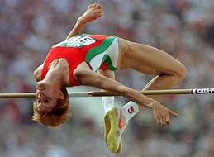
Stefka Kostadinova (Bulgaria) has held the women's world record at 2.09 m (6 ft 10 ¹⁄₄ in) since 1987, also the longest-held record in the event. https://www.youtube.com/watch?v=taDlHrfbe5g

High jump techniques:
For a Fosbury flop depending on the athletes jump foot they will start on the right of left of the mat. Placing their jump foot furthest away from the high jump mat. The athlete will have an eight to ten step approach in total, the last five steps being a curve with three or five steps before on a straight. The athlete will want to mark their approach to attempt to find as much consistency as possible. The athlete's non take off leg knee will naturally turn their body placing them in the air with their back to the bar. The athlete will then drive their shoulders to the back of their feet arching their body over the bar. The athlete can look over their right should then judge appropriately when to kick both feet over their head causing their body to miss the body and land on the mat

Question time:
What are the two popular techniques used in High Jump?
In what year did Stefka Kostadinova achieve the world record?
What angle to most runners run at the bar?
When did High Jump become an Olympic sport for men?
How many attempts are athletes allowed at each height?

