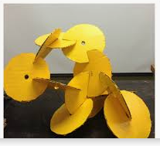
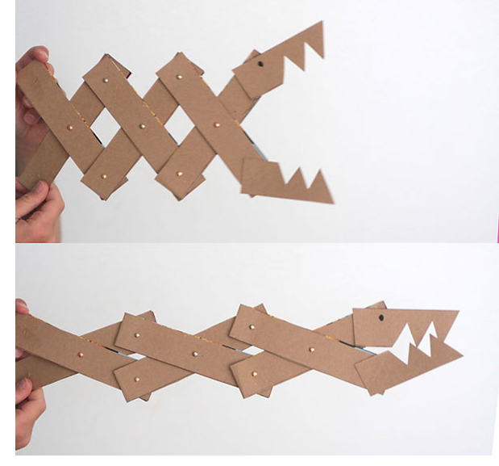
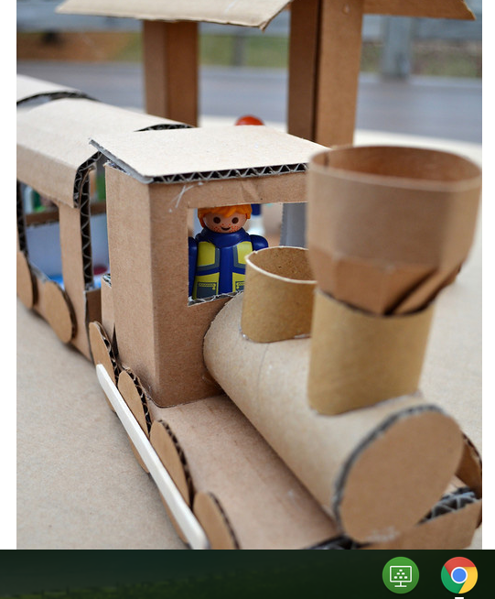
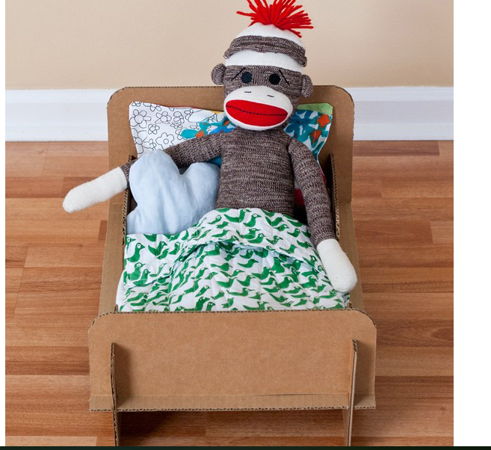

Design Brief for Year 8 DT
As a society we throw away huge amounts of packaging. Retailers are working towards reducing the amount of materials they use in product packaging. As consumers and designers, we need to help reduce the waste by recycling/up-cycling where we can.

You are aiming to design and make a child's toy from household cardboard.

Equipment you could use includes:
- Something to join your card together, this could be sticky tape, Sellotape, masking tape or paper fasteners. Don’t worry if you don’t have these you can design your toy with slits to insert (see the bed above)
- You will need old cereal boxes or any type of thin card, toilet roll also help
- Scissors and a pencil and ruler will also help.

Success Criteria
- The toy should be functional and have a good quality finish - plan, measure, accurate cutting out, consider where and how you will join your parts. Cut tape rather than tear it. Don't use more tape than needed.
- It should be designed for children within one of these age brackets 2-5, 6-8 or 9-11 (It is up to you to choose)
- It should encourage Imagination or be educational (go to www.itsalwaysautumn.com/20-coolest-toys-you-can-make-from-cardboard.html Use this research as inspiration for your own ideas.
- You should think about your chosen target age range and list the things you think they would like in a new toy. Even better if you have a younger sibling that you can ask or do some internet research!
- The product should be no smaller than 150x150mm and no larger than 350x350
- You should sketch a range of ideas in pencil before you decide on an idea and create your product

Outcomes
- A finished product, A range of pencil sketched design ideas. Please take photos of your product and your sketches. If possible upload them to show my homework.

Deadlines
Week1 and 2 (29th June) Design and pencil sketch product – photograph to your teacher
Week 3 and 4 (12 July) Initial products created and photographed
Week 5 July 19 Final design photographed and emailed photographs.

